Pokhara University

Level: Bachelor | Semester – Spring | Year : 2008
Programme: BE |  | Full Marks: 100
Course: Applied Mechanics |  | Time : 3hrs.

Candidates are required to give their answers in their own words as far as practicable.
The figures in the margin indicate full marks.

Attempt all the questions.

 | - Three forces act on the bracket at O. Determine the magnitude and direction θ of F₁ so that the resultant force is directed along the positive A-a axis and has a magnitude of 800 N.  - A system of parallel forces acting on a lever is as shown in figure. Determine the magnitude, direction and position of resultant.  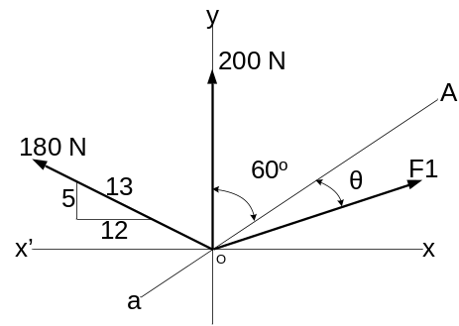  Fig 1.a  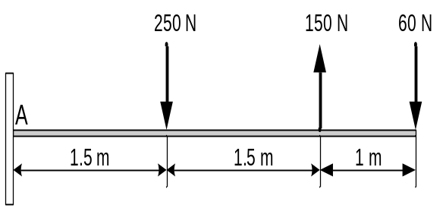  Fig 1.b | 8  7
 | - Determine the centroid of the section shown.  10cm  15cm  10cm  15cm  20cm  5cm  - A block weighing 600 N has been subjected to the load system as shown. Work-out the frictional force for the block and state whether it is in equilibrium or in motion. What additional force needs to be added to 120 N force so that the block just moves to the left? Take μ_{s} = 0.25 and μ_{k} = 0.2 | 8  7
 | - A golfer hits a golf ball with an initial velocity of 45 ms⁻¹ at an angle of 25º with the horizontal. Knowing that the fairway slopes downward at an average angle of 5º, determine the distance d between the golfer and point B where the ball first lands.  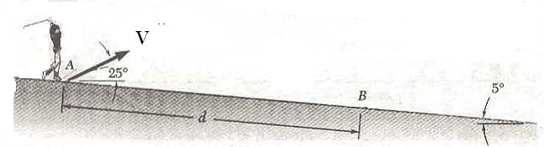  - The two dimensional motion of a particle is define by the relation r = 2b cos αt, where b and α are constants. Determine velocity and acceleration of the particle at any instant. | 7  8
 | Two blocks are originally at rest. Neglecting the mass of the pulleys and effect of friction in the pulleys and between block A and the incline is (µ = 0.2}. Determine acceleration of each block and tension in the cable.  160Kg  A  100Kg  30⁰  B | 15
 | A 2 Kg collar is attached to a spring and slides without friction in a vertical plane along a curved rod ABC. The spring is undeformed when the collar is at C and its constant is 800 N/m. If the collar is release at a with no initial velocity, determine its velocity (a) as it passes through B, (b) as it reaches C.  C  D  100mm  250mm  B  A  200mm | 15
 | - The 30 kg disk shown in figure is pin supported at its center. Determine the number of revolutions it must make to attain and angular velocity of 20 rad/s starting from rest. It is acted upon by a constant force F = 10 N, which is applied to a cord wrapped around its periphery, and a constant couple M = 5 Nm. Neglect the mass of the cord in the calculation.  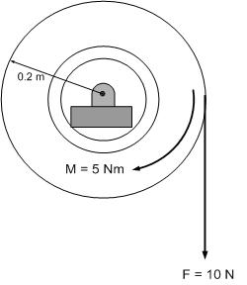  OR | 15
 | - A 120 × 180 cm² rectangle plate weighting 100 N is suspended from two pins A and B. If pin B is suddenly removed, determine angular acceleration of plate.  A  B  120 cm  180 cm  - A rigid body is rotating at the rate of 10 rad/s about an axis through the origin. The axis has direction cosine 0.268, 0.432 and 0.861 with respect to X, Y and Z axes respectively. What is the linear velocity in meter per second of the point in the body whose position vector in meter with respect to the origin is r = 4i – 2j + 3k. | 7  8
 | Write short notes on (Any Two):  - Parallel axis theorem  - Translation  - General Plane Motion  - Projectile | 2×5

